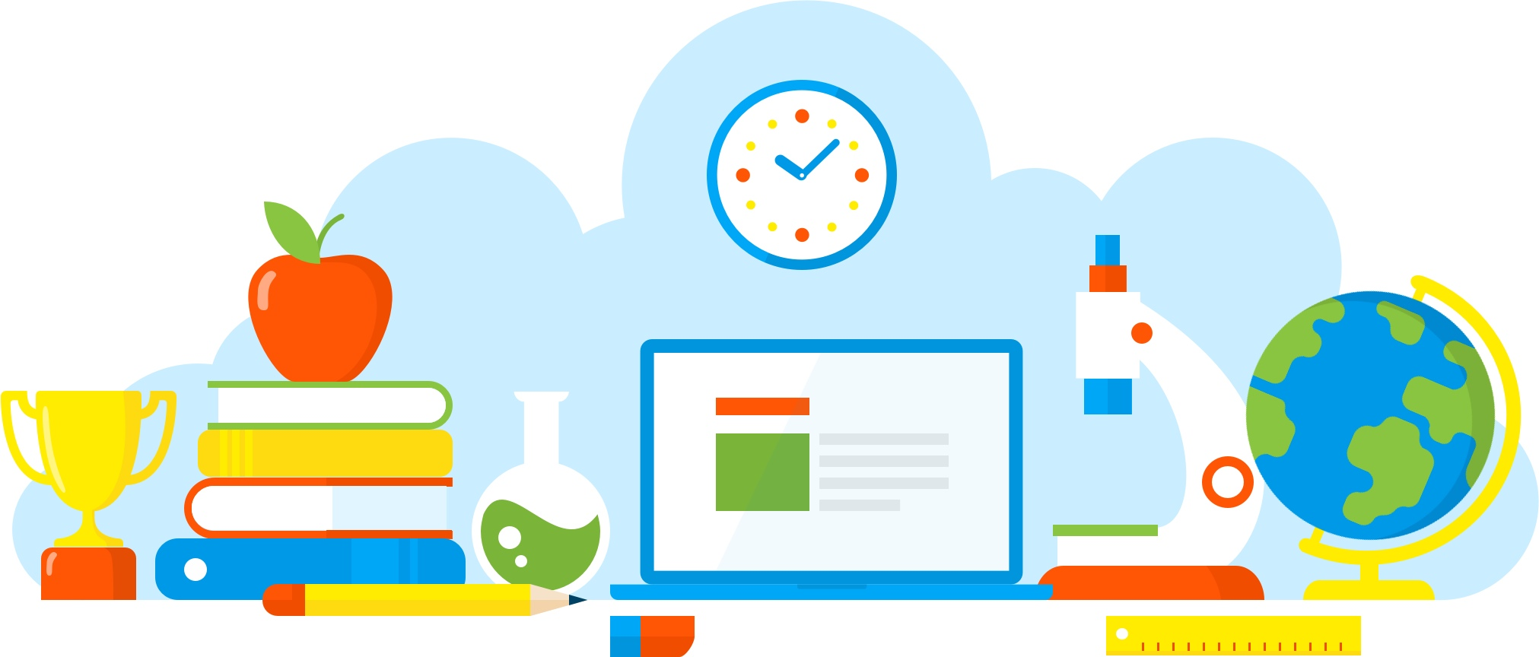

Universal Design for Learning Resources

Introduction
CAST (Center for Applied Science Technology) developed Universal Design for Learning (UDL), a framework that recognizes learner variability and is a blueprint for creating instructional goals, methods, materials, and assessments that work for everyone–not a single, one-size-fits-all solution but rather flexible approaches to teaching and learning. With UDL, we start with high standards for all and apply flexible means so that each learner finds appropriate learning challenges and supports. In fact, the UDL framework helps educators to maximize “desirable challenges” (such as the challenge to meet high standards) and minimize “undesirable” ones (such as frustration and boredom). With UDL we optimize learning opportunities for all. http://castprofessionallearning.org/about-udl/

There are a lot of resources available for educators at all levels of UDL implementation. The following is not complete - it contains reliable resources (websites, books, and links) - many free for educators to explore, use, and share.
Resources
Websites:
Center for Applied Science Technology: CAST: Home
This website offers UDL resources for everyone. Whether you are starting from scratch and need UDL101 or if already have the basics and are ready to expand your knowlege and/or design lessons.

The Universal Design for Learning Implementation and Research Network: UDL-IRN | The Universal Design for Learning Implementation and Research Network
This website offers resources and learning for implementation, research, and networking. UDL-IRN also offers a variety of Professional Learning opportunities to expand your knowledge and build your capacity.

Books:
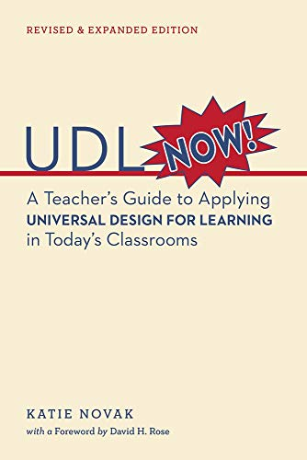 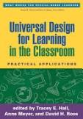 - 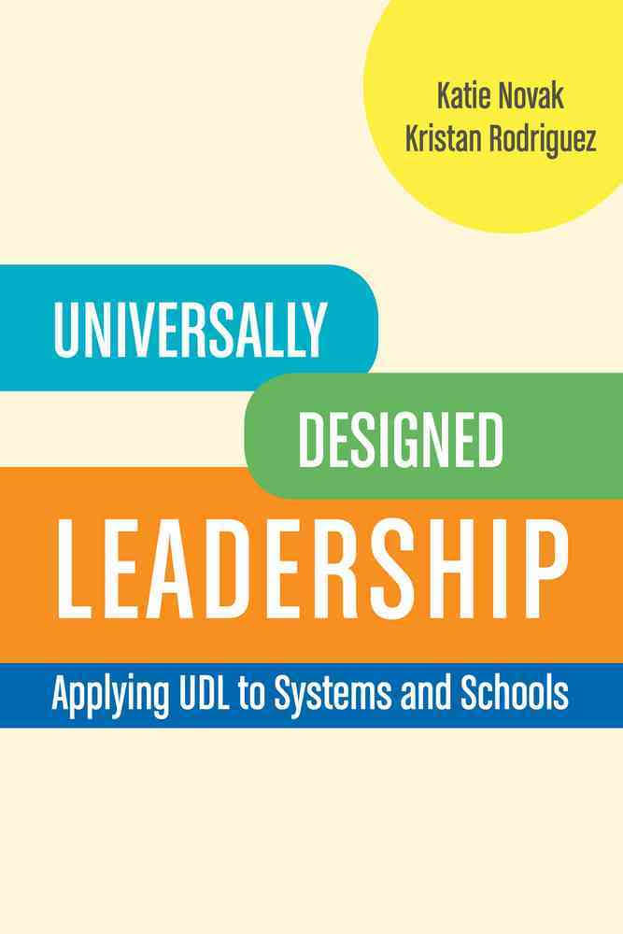 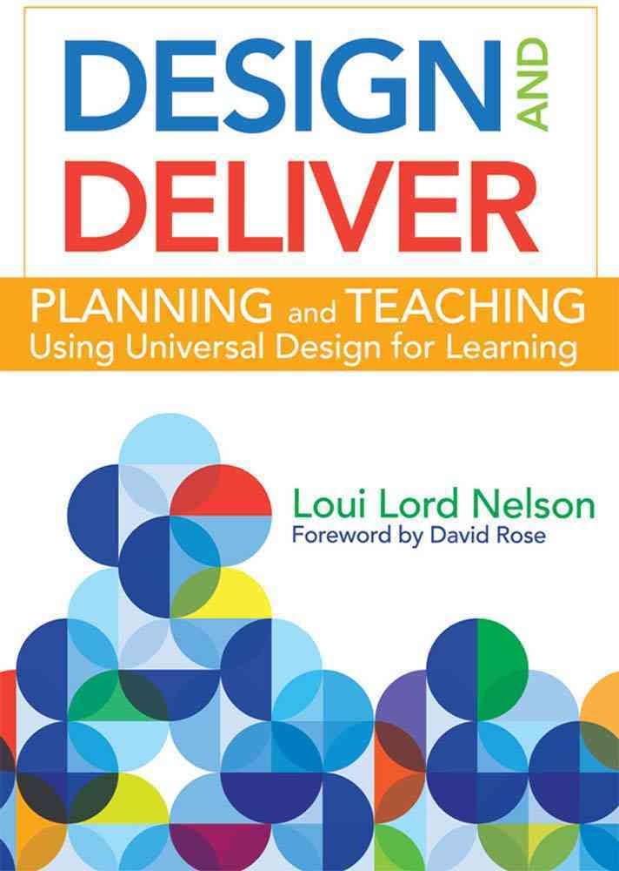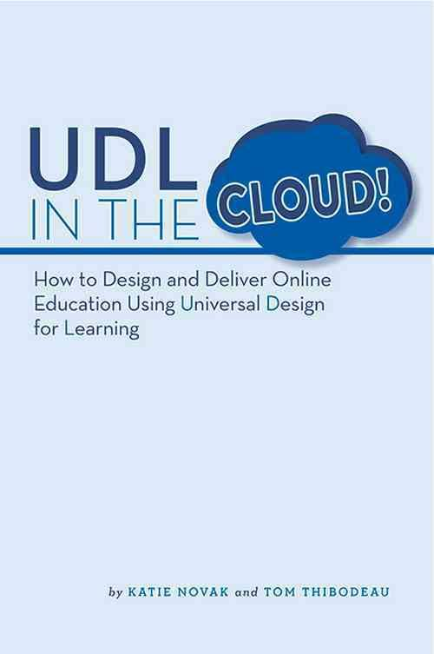 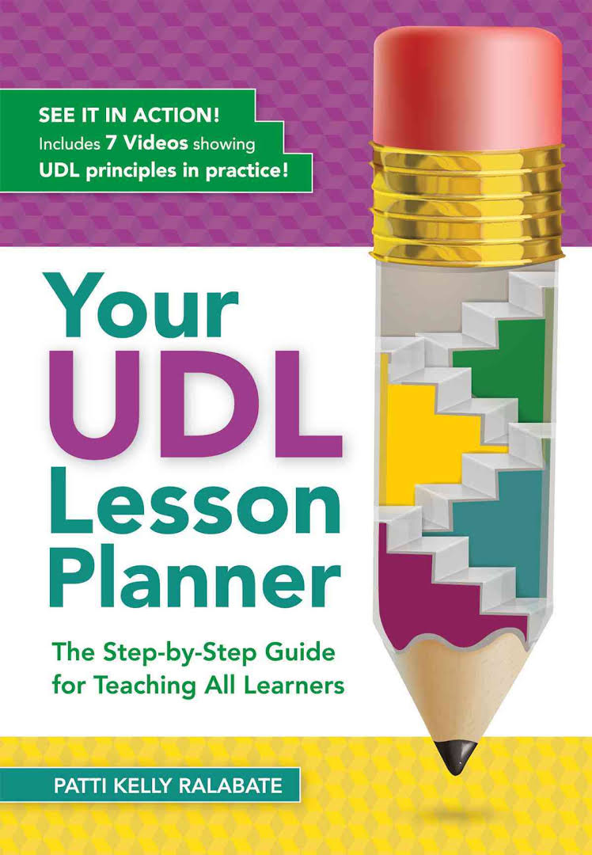 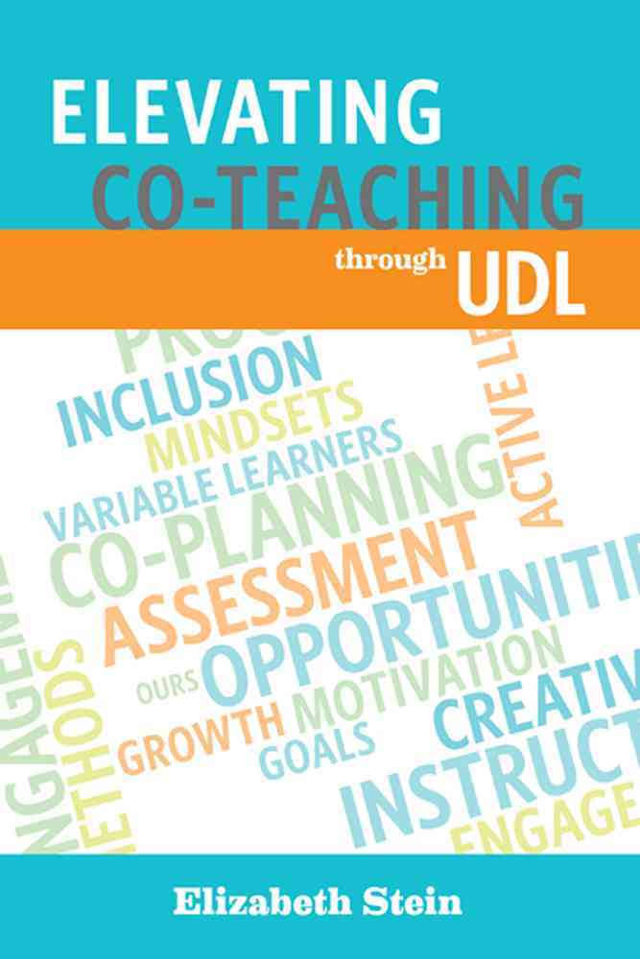 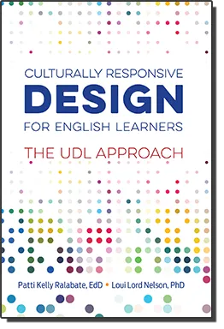 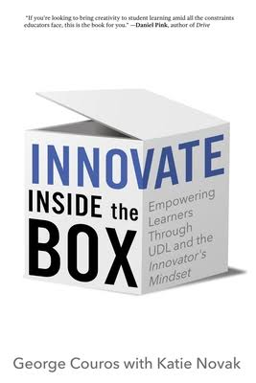 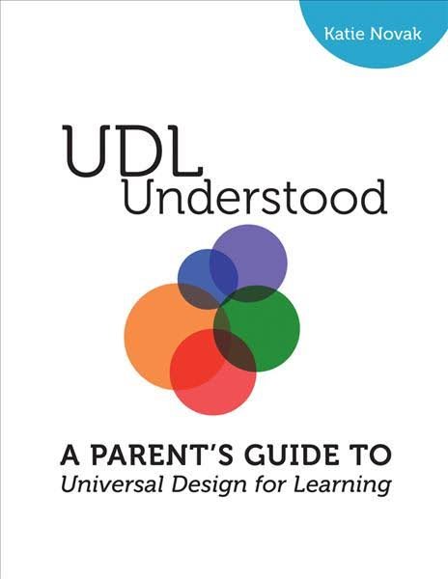 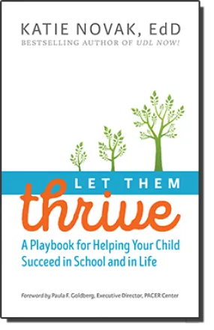

Other:
- Homeschool plan for parents and caregivers trying to support the continuation of learning in your home. This offers a daily schedule and activities universally designed by Katie Novak (UDL NOW!) and Alison Sancinito.

- Equal access to digital curriculum. With more schools moving to remote learning platforms due to COVID-19, we must ensure that all learning remains accessible to ALL learners. In addition, we must ensure that students receiving supports via an IEP (AT devices and services, therapy services, other related services) are having their needs met in this remote learning environment. The link will take you to a document with some strategies/resources/ideas to provide access to ALL learners.

- #myohioclassroom - connect globally with educators on Twitter to share and find resources.

- https://applieddigitalskills.withgoogle.com/s/en/home - Ready-to-use video lessons teach digital skills that have immediate, real-life application.

- https://teachfromhome.google/intl/en/ - Educator support for those trying to work from home.

